2. Git-HOL :
File & Directory Setup Commands
- cd GitDemo
  - Navigates your terminal shell into your project repository directory.
- echo "This is a temporary system log" > app.log
  - Creates an un-tracked .log file in the root directory.
- mkdir log
  - Creates a new directory named log.
- echo "Database connection error log" > log/error.log
  - Creates a .log file inside the newly created log folder.
- notepad .gitignore
  - Opens or creates the .gitignore file in Windows Notepad to define ignore rules.
🔄 Git Tracking & Verification Commands
- git status
  - Displays the status of untracked files before and after creating .gitignore to verify files are ignored.
- git add .gitignore
  - Stages the .gitignore file so Git can track your configuration rules.
- git commit -m "Add .gitignore to ignore log files and folder"
  - Saves the .gitignore file into your local Git repository history with a commit message.
- git push origin main
  - Uploads your .gitignore file to your remote repository on GitHub/GitLab.
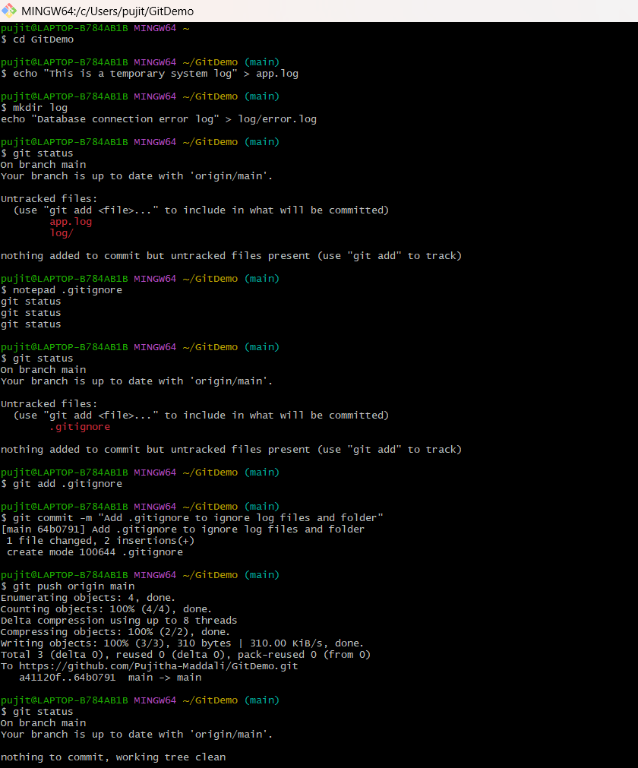

.gitignore commited into GitHub:
